# MINI PROJECT – I

## (2019-20)

**Shopping Website**

**MID TERM REPORT**

**Institute of Engineering & Technology**

# Avyakt Pratap Singh

# Roll No: 171500069

# Abhishek Kumar

# Roll No:171500010

# Krishna Kant Singh

Roll No:171500164

***Supervised By***

### Harvinder Kaur

**Technical Trainer**

**Department of Training and Placement**

**Abstract**

This mid-term mini project report documents the amount of work done in the Mini Project during this date. The report first shall give an overview of the tasks completed during this period with technical details. Then the results obtained shall be analyzed. Report shall also elaborate on the future works which are still to be persuaded as an advancement of current work. I have tried my best to keep the report simple yet technically correct. I hope I succeed in my attempt.

**Index**

|  |  |
| --- | --- |
| 1. Introduction | 3 |
| 2. Problem Definition | 4 |
| 3. Objectives | 4 |
| 4. Methodology | 4 |
| 5. Implementation Details | 5 |
| 6. Work Progress | 5 |
| 7. DFD | 5 |
| 8.Referecees | 8 |

**Introduction**

The major feature of this web application is to help the user to buy the product of their choice where a large number of product are availale in the market which makes the user a bit in a cofusion . It lists all the type of product and its all relevant information . It also features a personalized filtered search with a login and signup module which will allow the users to log in to their profile and view their previous history. The application is in development with all the modern Full Stack technologies. It would be made fully responsive to render across all the different devices..

### Area of Development

This project deals with the area of Web Development. The whole application runs on ReactJS with JavaScript providing solid back end foundations. It is being developed with major Web Development Technologies like HTML, CSS, JavaScript and ReactJS.

### Requirements

1. **Hardware:**
   * A computer or any portable device connected to the internet and with bare minimum specifications.

### Software:

* + Standard Web Browser like Chrome, Safari or Firefox.
  + ReactJS
  + JavaScript

## The Problem Definition

We are not able to get a user friendly shopping wesite.we are not abl e to find everything at the same place.

## Objective of the project

This project is aimed at developing a Web application that depicts of accessories and purchasing using Payment Gateway. Using this software, people can improve the efficiency of their service. Online Shopping is one of the applications to improve the marketing of the company’s products. This website involves all the features of the online shopping.

## Methodology of the project

The project is currently in full development using Web Development technologies. The application uses JavaScript on backend with the power of React to handle requests queried by the user. The server makes the request to database and fetches the results according to the query made by the user. For instance, if the user searches any cloth product then it display all the cloth related products. The user get full details like price of the product its seller and other relevant information to the user. The biggest feature is that this application recommends product on the basis of the query requested by the user with all its details. User can buy the product of their choice and make payment for the product.

## Implementation

Just like every other application, this too has two major parts. The front end and the back end. The Frontend end part relies on HTML and CSS. This is then styled and made to render in the browser. All the relevant information are fetched and are carefully laid on the web page. The backend is supported by the JavaScript. All the Webpages are connected with the help of React.

## Work Progress

The project is almost halfway complete. All the Frontend related work is complete and the rest is under way. At this stage the homepage display all the products and they can also be added to the cart .Paymet module has been also added. All the styling work is done.

Now, there are things that are still left undone. Search module for the product is not completed . search module can help the user to search product on the basis of their interest. Login and signup for the user is still not done. Tracking of product ordered by the user is still left.

The application can be cloned or downloaded from:

https://github.com/Krishnakant14/mini-project-fullstack

DFD

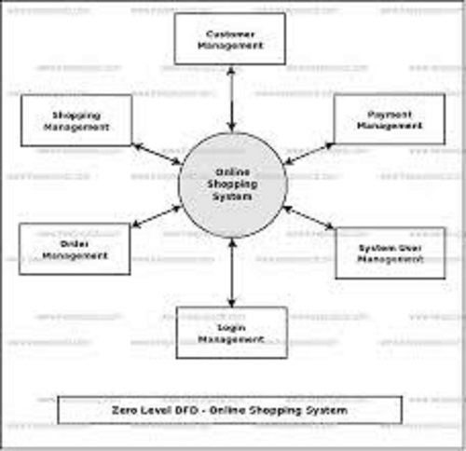

Some screeshots

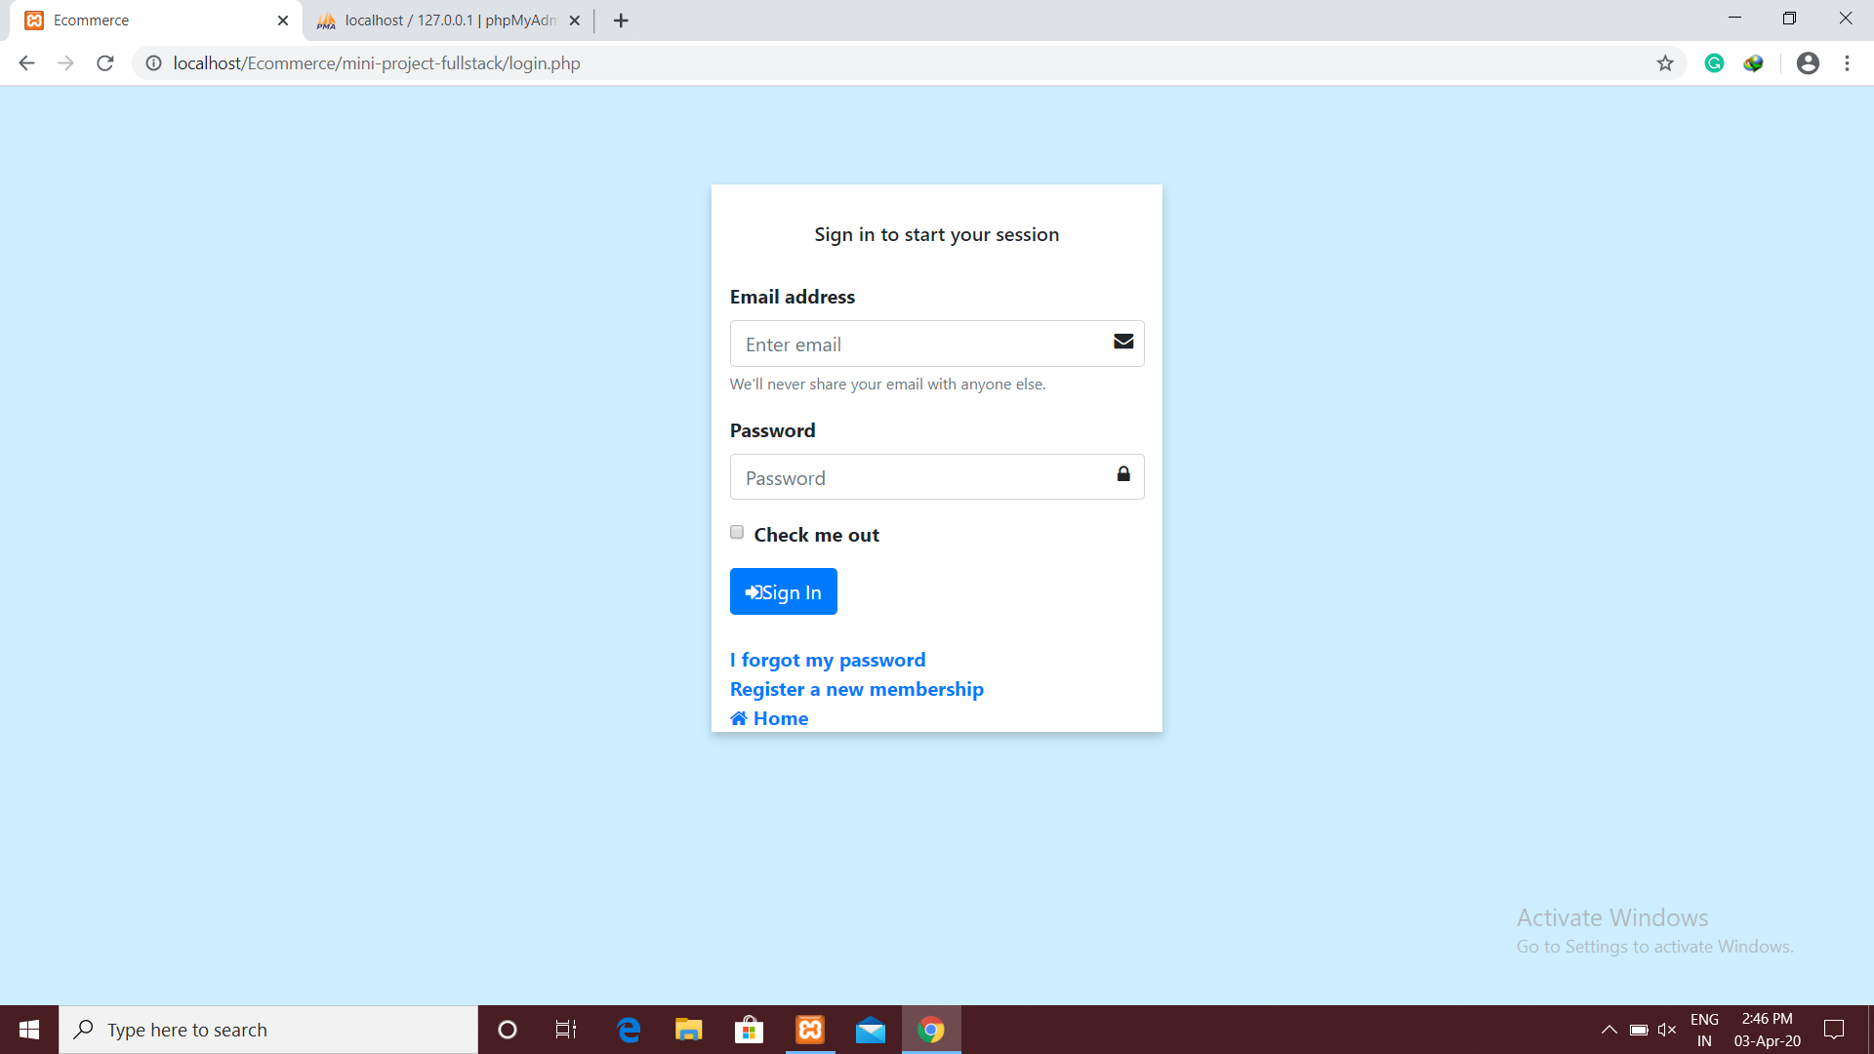

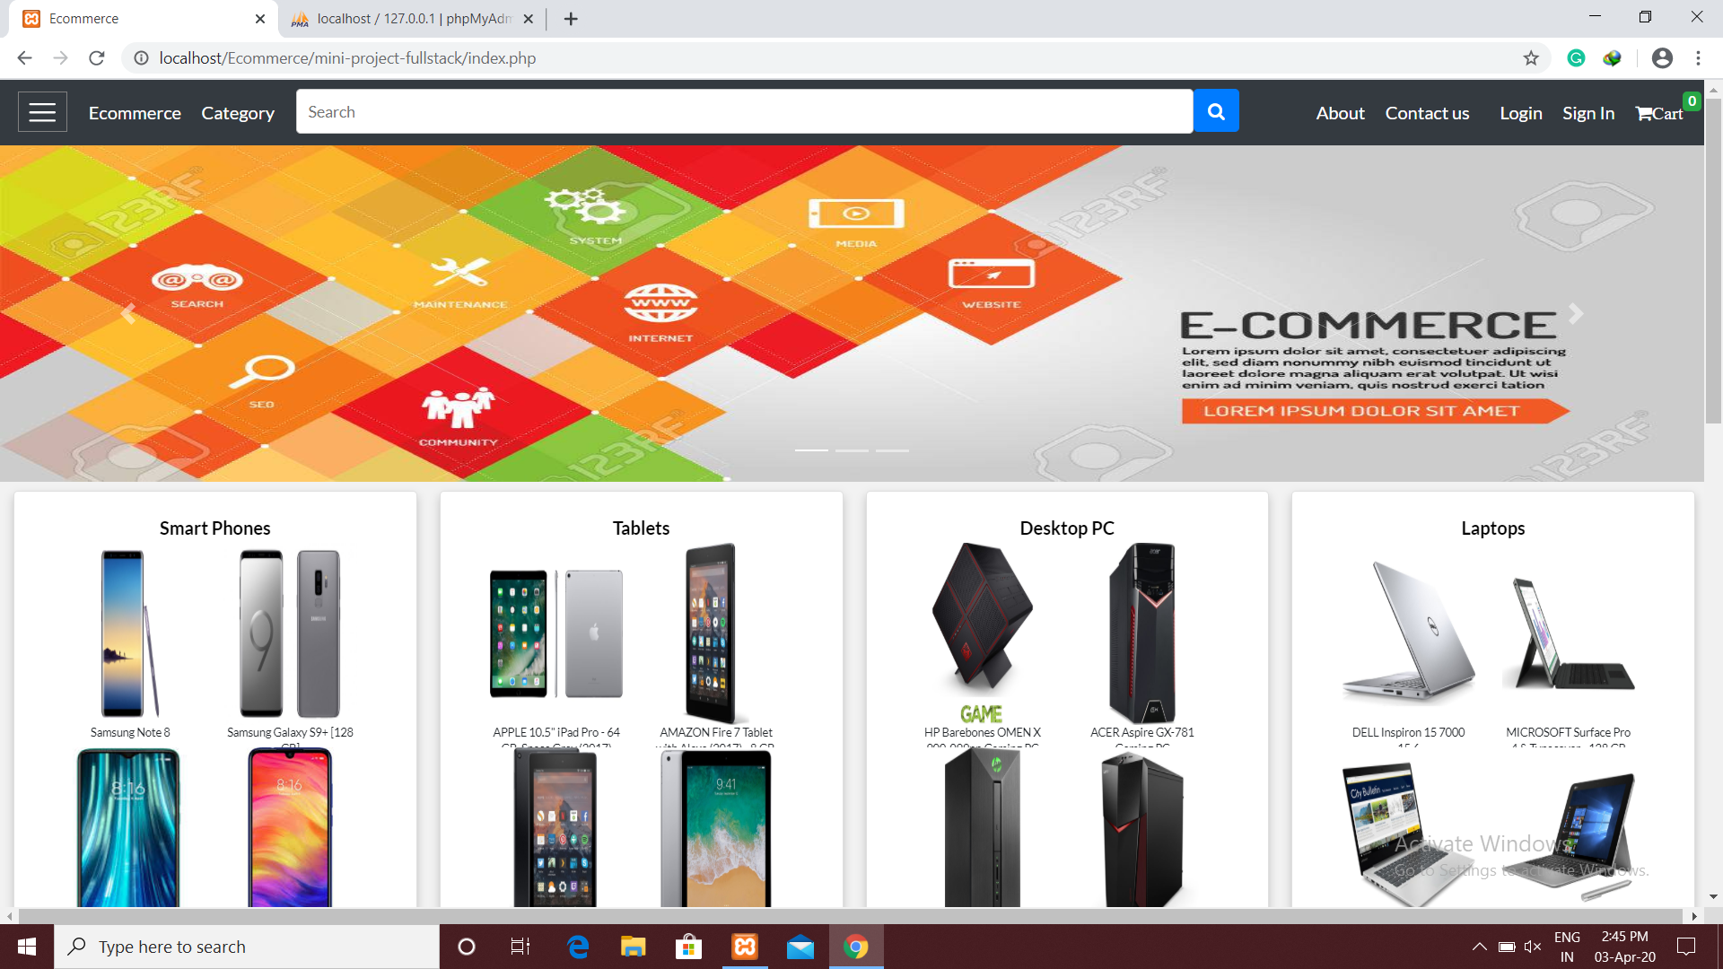

**Cotribution summary**

All the work done up till now in the website is done with the contribution of both of us helping each other in each technologies used in the making of the project.we have discussed each other before using

any implementation of any part of the website.

## References

## <https://reactjs.org/>

## <https://www.w3schools.com/>

## <https://www.tutorialspoint.com/index.htm>

## <https://www.geeksforgeeks.org/>